**Sprint – 2**

|  |  |
| --- | --- |
| Date | 04 November 2022 |
| Team ID | PNT2022TMID32303 |
| Project Name | Estimate the crop yield using Data Analytics |

# Data Visualization Charts:

* Login to IBM Cognos then in open menu click **New -> Dashboard .**

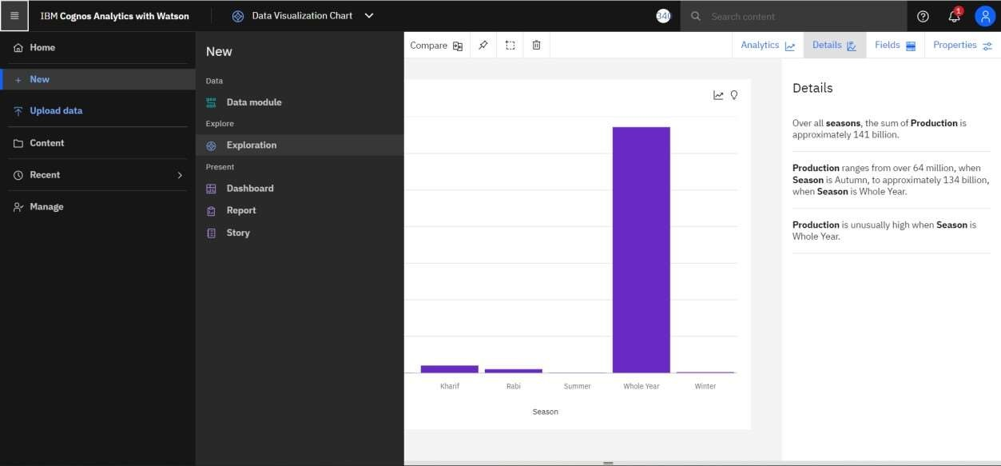

* Select a template for your dashboard and click create.

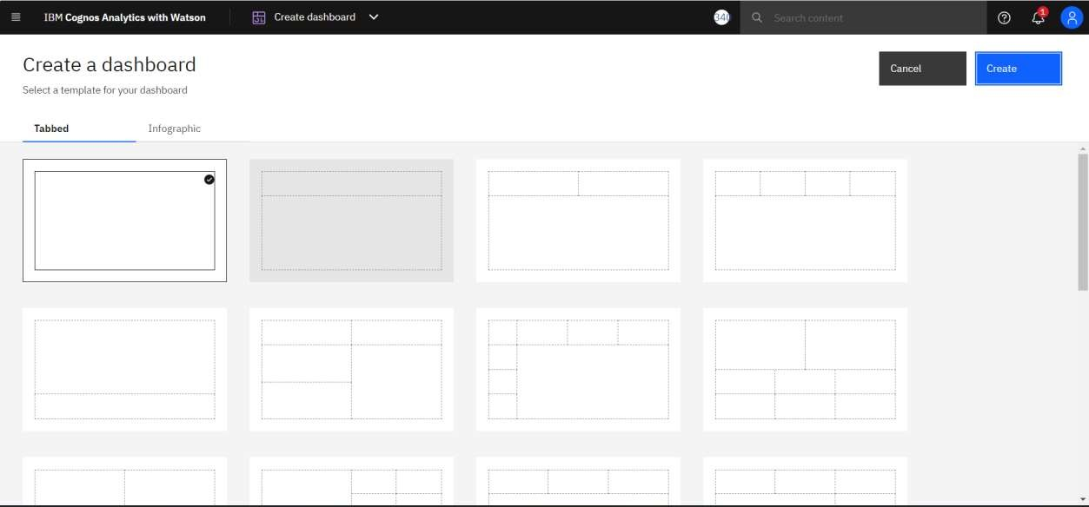

* Then select the **crop_production.csv** dataset under my content tab and click **add** In Add a source.

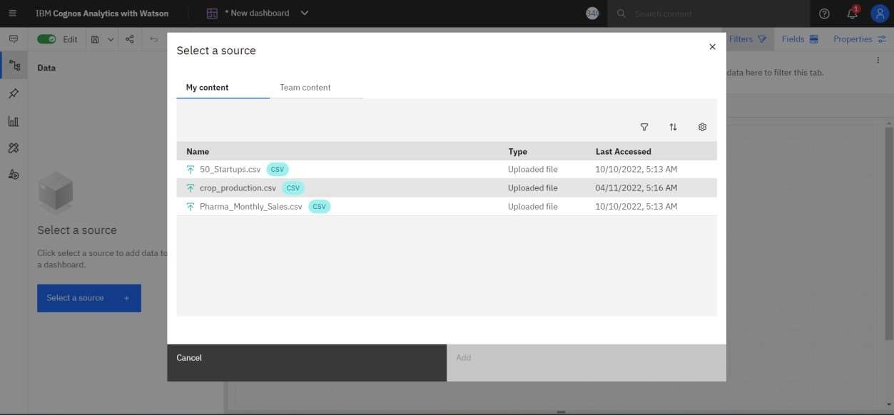

* Rename the tab title

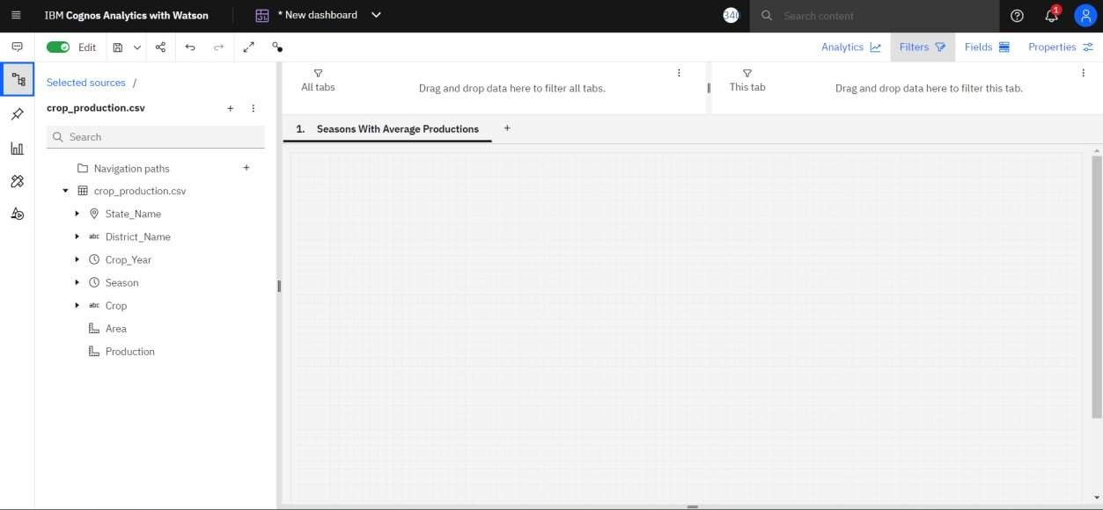

* Select the visualizations and select the system you want.

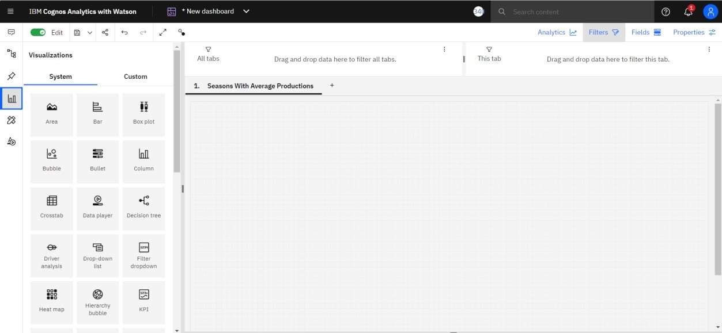

# Seasons With Average Productions

* Select the column in choose visualization and in fields select “Season” for Bars and “Production” for Length.

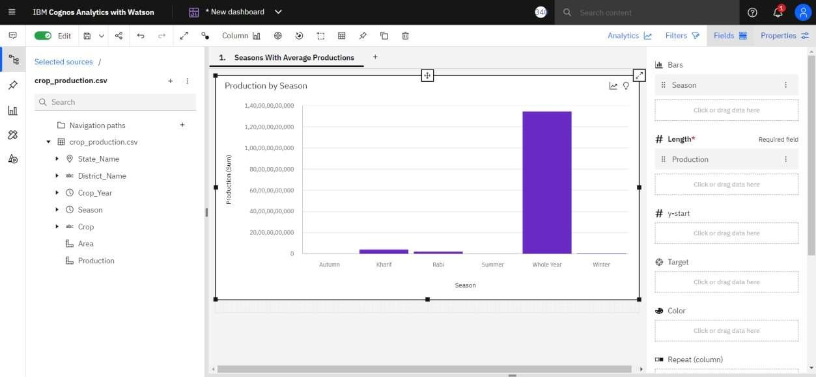

# With Years Usage Of Area Production

* Select the Area in choose visualization and in fields select "Crop_Year” for X-axis and “Area” for Y-axis.

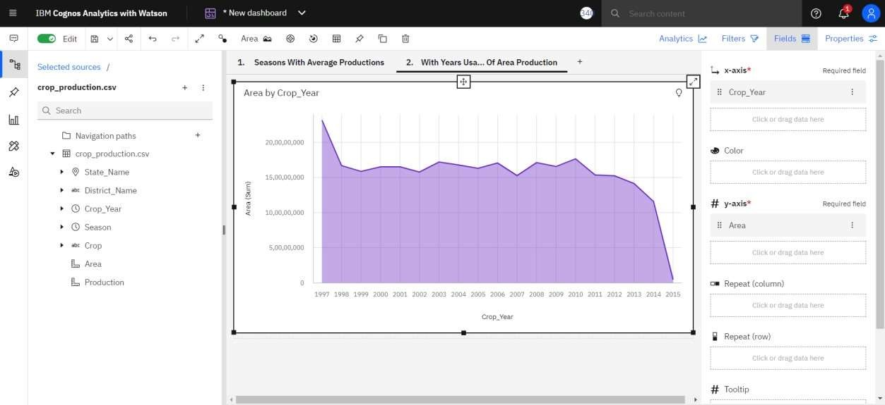

# Top 10 States With Most Area

* Select the column in choose visualization and in fields select “State_Name” for Bars , “Area” for Length “State_Name” for Color.
* Select three dots in Area -> Summarize -> Average.
* In Area click on the three dots then select Top or bottom
* In Number of Result Enter 10 and select the **Top count** .

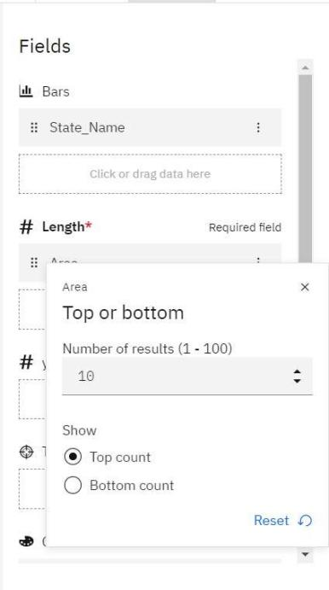

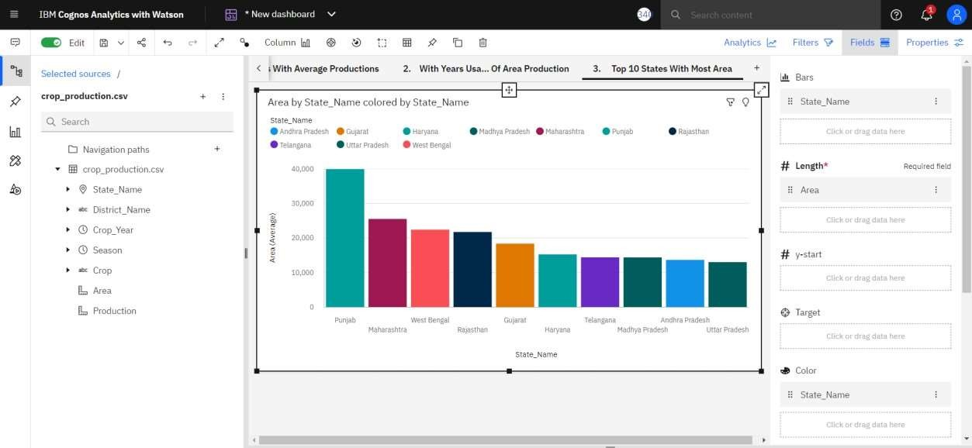

# State With Crop Production

* Select the Map in choose visualization and in fields select “State_Name” for Location and “State_Name and Crop” for Location Color.
* Click three dots in the Crop then select filter and choose particular crop that you want then click done.

